**Experiment: 1**

**Aim:** Write a program to print student detail (Name, Roll No, Branch and Department)

**Software:** Dev C++

**Code:**

#include<stdio.h>

int main(void)

{

printf("Name of Student Is Mr.Linen\n");

printf("Roll No of student Is 101010\n");

printf("He Is From ICT Branch");

return 0;

}

**Output:**

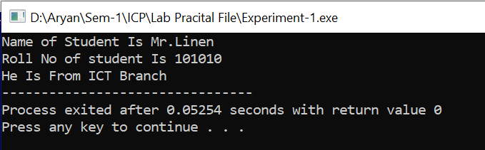

**Experiment: 2**

**Aim:** Write a program to calculate simple interest.

**Software:** Dev C++

**Code:**

#include<stdio.h>

#include<conio.h>

int main()

{

double p,r,n,i;

printf("Enter The Principle Value:-");

scanf("%lf",&p);

printf("Enter The Rate Of Interest:-");

scanf("%lf",&r);

printf("Enter The Time Period:-");

scanf("%lf",&n);

i=p*r*n/100;

printf("The Simple Interest is %.2lf",i);

return 0;

}

**Output:**

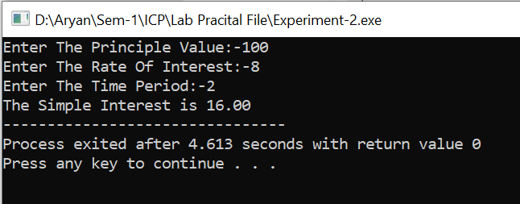

**Experiment: 3**

**Aim:**  Write a program that accepts centigrade and convert it into Fahrenheit

**Software:** Dev C++

**Code:-**

#include<stdio.h>

#include<conio.h>

int main()

{

float centigrade,Fahrenheit;

printf("Enter The Temperature In Centigrade:-");

scanf("%f",&centigrade);

Fahrenheit = 1.8 * (centigrade) + 32 ;

printf("The Temperature In Fahrenheit Is %.2f",Fahrenheit);

return 0;

}

**Output:**

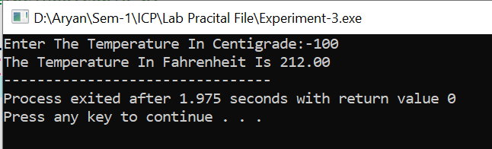

**Experiment: 4**

**Aim:**  Write a program that accepts two numbers in A and B interchange value of A and B  
variable..

**Software:** Dev C++

**Code:-**

#include<stdio.h>

#include<conio.h>

int main()

{

int A,B;

printf("Enter The Value Of A:-");

scanf("%d",&A);

printf("Enter The Value Of B:-");

scanf("%d",&B);

printf("Before Swap\nA=%d\nB=%d\n",A,B);

A=A+B;

B=A-B;

A=A-B;

printf("After Swap\nA=%d\nB=%d\n",A,B);

return 0;

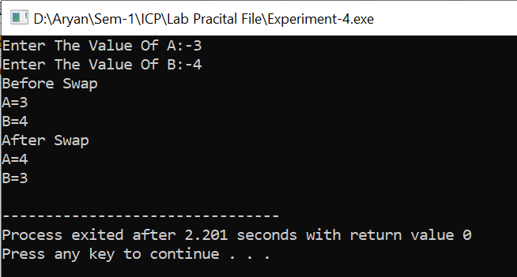

}

**Output:-**

**Experiment: 5**

**Aim:-**  Write a program that perform the following output for n rows

**Software:-** Dev C++

**Code:-**

#include<stdio.h>

int main()

{

int a;

printf("Enter A Integer:-");

scanf("%d",&a);

printf("Integer:-%d\n",a);

printf("Float Is:-%f\n",(float)a);

printf("Character Is %c",a);

return 0;

}

**Output:-**

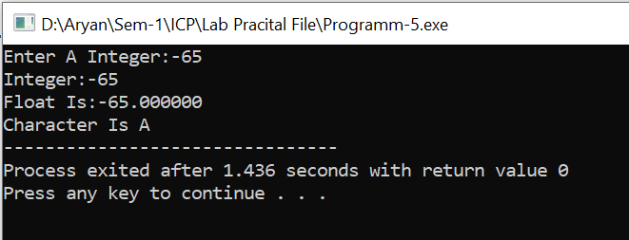

**Experiment: 6**

**Aim :-**  Write a program to demonstrate the use of Arithmetic operators by getting two  
numbers from the user

**Software:-** Dev C++

**Code:-**

#include<stdio.h>

int main()

{

int a,b;

printf("Enter The First Value:-");

scanf("%d",&a);

printf("Enter The Second Value:-");

scanf("%d",&b);

printf("Addition Is %d\n",a+b);

printf("Substraction Is %d\n",a-b);

printf("Multiplication Is %d\n",a*b);

printf("Division Is %d\n",a/b);

printf("Modulo Is %d",a%b);

return 0;

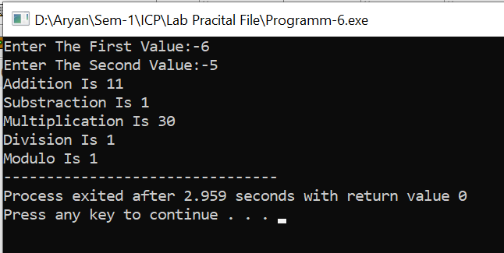}

**Output:-**

**Experiment: 7**

**Aim:-**  Write a program that accepts a number from keyboard and find weather the number is

ODD or EVEN using Conditional operators.

**Software:-** Dev C++

**Code:-**

#include<stdio.h>

int main()

{

int num;

printf("Enter A Number:-");

scanf("%d",&num);

(num%2==0) ? printf("%d Is A Even Number",num) : printf("%d Is A Odd Number",num) ;

return 0;

}

**Output:-**

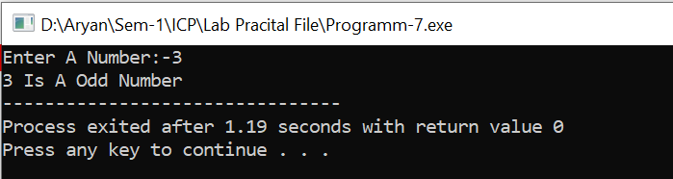

**Experiment: 8**

**Aim** Write a program to demonstrate the use of increment and decrement operator.

**Software:-** Dev C++

**Code:-**

#include<stdio.h>

int main()

{

int a,num;

printf("Enter The Number:-");

scanf("%d",&a);

num=a;

printf("Increment Is %d\n",a++);

printf("Decrement Is %d\n",--num);

return 0;

}

**Output:-**

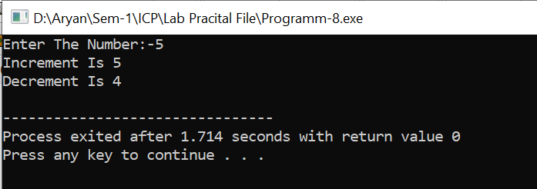

**Experiment: 9**

**Aim:-**  Write a program to demonstrate the use of shorthand operators.

**Software:-** Dev C++

**Code:-**

#include<stdio.h>

int main()

{

int a,b;

printf("Enter The First Value:-");

scanf("%d",&a);

printf("Enter The Second Value:-");

scanf("%d",&b);

printf("Or-Operator Is %d\n",a|=b);

printf("And-Operator Is %d\n",a&=b);

printf("Xor-Operator Is %d\n",a^=b);

printf("Left Shift-Operator Is %d\n",a<<=b);

printf("Right-Operator Is %d\n",a>>=b);

return 0;

}

**Output:-**

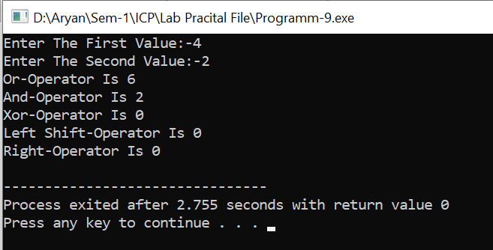

**Experiment: 10**

**Aim:-**  Write a program to demonstrate the use of sizeof() of operator.

**Software:-** Dev C++

**Code:-**

#include<stdio.h>

int main()

{

int a;

printf("Size Of a Integer Is %d",sizeof(a));

return 0;

}

**Output:-**

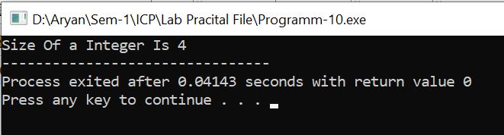

**Experiment: 11**

**Aim:** Write a program to demonstrate the use of bitwise operators.

**Software:** Dev C++

**Code:**

#include<stdio.h>

int main()

{

int a,b;

printf("Enter The Number-1:-");

scanf("%d",&a);

printf("Enter The Number-2:-");

scanf("%d",&b);

printf("The Bit-wise Or Operator Is %d\n",a|b);

printf("The Bit-wise And Operator Is %d\n",a&b);

printf("The Bit-wise xor Operator Is %d\n",a^b);

return 0;

}

**Output:**

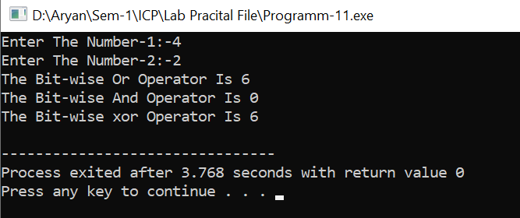

**Experiment: 12**

**Aim:** Write a program to find out the average of three numbers.

**Software:** Dev C++

**Code:**

#include<stdio.h>

int main()

{

int num,sum=0;

for(int i=1;i<=3;i++)

{

printf("Enter The Number-%d:-",i);

scanf("%d",&num);

sum=sum+num;

}

printf("The Sum Of All Three Numbers are %d\n",sum);

printf("The Average Of All Three Numbers are %d\n",sum/3);

return 0;

}

**Output:**

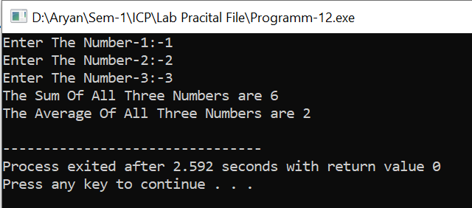

**Experiment: 13**

**Aim:**  Write a program to calculate the gross salary of a person if the user enters the basic

salary. Dearness Allowance (DA) should be 50 percent of basic salary, and House Rent Allowance (HRA) is 10 percent of basic salary.

**Software:** Dev C++

**Code:-**

#include<stdio.h>

int main()

{

int base_salary;

printf("Enter Your Base Salary:-");

scanf("%d",&base_salary);

printf("Your Base salary Is %d\n",base_salary);

printf("Your Dearness Allowance Is %.2f\n",0.5*base_salary);

printf("Your House Rent Allowance Is %.2f\n",0.1*base_salary);

printf("\n\n\n");

printf("Your Total Salary Is %.2f\n",1.6*base_salary);

return 0;

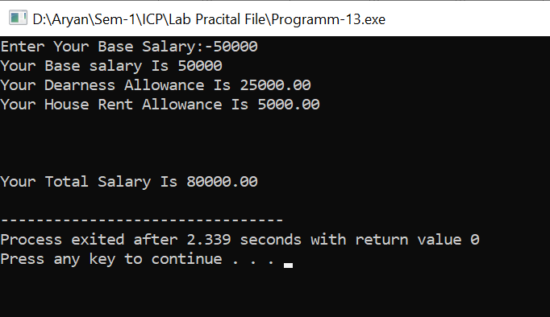}

**Output:**

**Experiment: 14**

**Aim:**  Write down a program to calculate the compound interest

**Software:** Dev C++

**Code:-**

#include<stdio.h>

#include<math.h>

int main()

{

double principle_amount,rate_of_interest,compound_interest;

int no_of_years;

printf("Enter Your Principle Amount:-");

scanf("%lf",&principle_amount);

printf("Enter Your Rate Of Interest:-");

scanf("%lf",&rate_of_interest);

printf("Enter The Number of Years:-");

scanf("%d",&no_of_years);

compound_interest=principle_amount*pow((1+(rate_of_interest/100)),no_of_years)-principle_amount;

printf("The Compound Interest at %d Years Is %.2lf",no_of_years,compound_interest);

return 0;

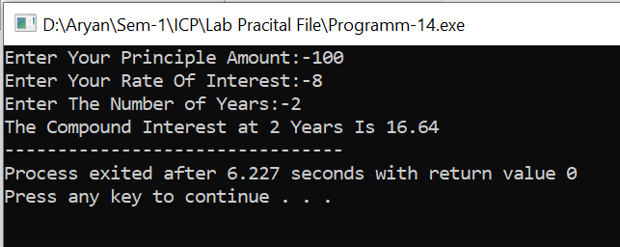

} **Output:-**

**Experiment: 15**

**Aim:-**  Write a program that accepts three numbers from the user and print maximum of them.

**Software:-** Dev C++

**Code:-** **Output:-**

#include<stdio.h>

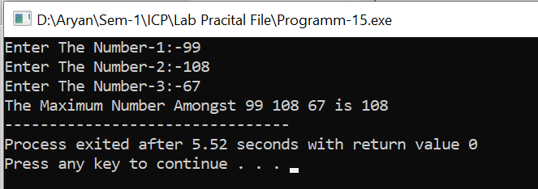int main()

{

int a,b,c,max;

printf("Enter The Three Numbers:-");

scanf("%d %d %d",&a,&b,&c);

if(a>b)

{

if(a>c)

max=a;

else

max=c;

}

else

{

if(b>c)

max=b;

else

max=c;

}

printf("The Maximum Number Amongst %d %d %d is %d",a,b,c,max);

return 0;}

**Experiment: 16**

**Aim :-**  Write a program that accepts two numbers and one code (1,2,3,4) from the user.

According to the code, the operations to be performed, using switch case statements as follows: (Code: 1→ Addition, 2→ Subtraction, 3→ Multiplication, 4→ Division).

**Software:-** Dev C++

**Code:-**

#include<stdio.h>

int main()

{

int a,b,op;

printf("Enter The First-Number:-");

scanf("%d",&a);

printf("Enter The Second-Number:-");

scanf("%d",&b);

printf("Enter The Operation:-");

scanf("%d",&op);

switch(op)

{

case 1:

{

printf("The Addition Is %d",a+b);

break;

}

case 2:

{

printf("The Substraction Is %d",a-b);

break;

}

case 3:

{

printf("The Multiplication Is %d",a*b);

break;

}

case 4:

{

printf("The Division Is %d",a/b);

break;

}

}

}

**Output:-**

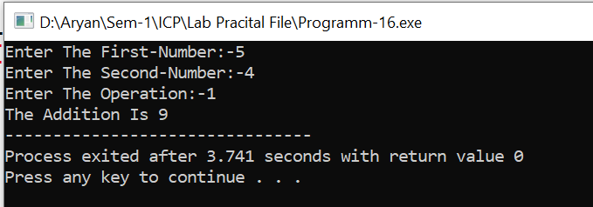

**Experiment:17**

**Aim:-**  Write a program that reads the marks for five subjects of a student. Calculate and print

the grade for the student [i.e. Grade A, B, C, D and F] using Else-If ladder.

**Software:-** Dev C++

**Code:-**

#include<stdio.h>

int main()

{

int a,sum=0,avg=0;

for(int i=1;i<=5;i++)

{

printf("Enter The Marks-%d:-",i);

scanf("%d",&a);

sum=sum+a;

}

avg=sum/5;

if(avg>=90)

{

printf("Grade-A");

}

else if(avg>=80 && avg<90)

{

printf("Grade-B");

}

else if(avg>=70 && avg<80)

{

printf("Grade-C");

}

else if(avg>=60 && avg<70)

{

printf("Grade-D");

}

else if(avg>=50 && avg<40)

{

printf("Grade-E");

}

else if(avg>=33 && avg<40)

{

printf("Grade-F");

}

else

{

printf("FAIL");

}

return 0;

}

**Output:-**

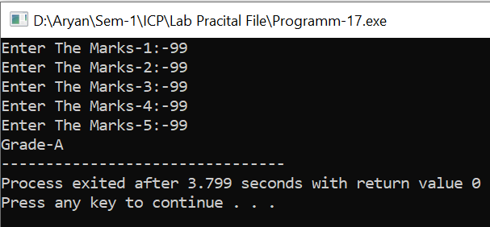

**Experiment: 18**

**Aim:-**  Write a program that do sum=1+3+5+……. N terms Print value of Sum..

**Software:-** Dev C++

**Code:-**

#include<stdio.h>

int main()

{

int num,sum=0;

printf("Enter The Value Of N:-");

scanf("%d",&num);

for(int i=1;i<=num;i++)

{

if(i%2 !=0)

{

sum=sum+i;

}

}

printf("Addition Is %d",sum);

return 0;

}

**Output:-**

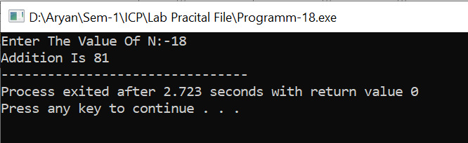

**Experiment: 19**

**Aim:-**  Write a program to print the Fibonacci Series [i.e. 1,1,2,3,5,8,13…N terms].

**Software:-** Dev C++

**Code:-**

#include<stdio.h>

int main(void)

{

int a=0,b=1,c,n;

printf("Enter The Value Of N:-");

scanf("%d",&n);

printf("%d %d ",a,b);

for(int i=1;i<=n;i++)

{

c=a+b;

a=b;

b=c;

printf("%d ",c);

}

return 0;

}

**Output:-**

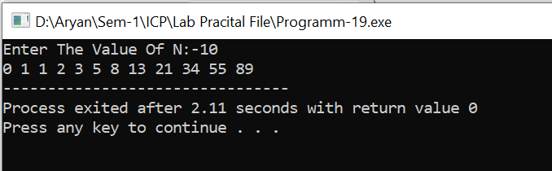

**Experiment: 20**

**Aim:-**  Write a program that accepts a number from the user and print prime numbers from 0 to that number.

**Software:-** Dev C++

**Code:-** **Output:-**

#include<stdio.h>

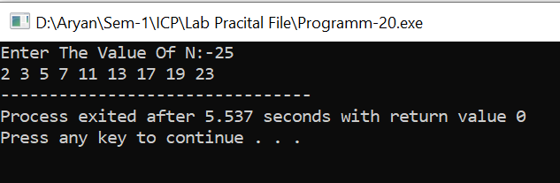int main()

{

int n,j;

printf("Enter The Value Of N:-");

scanf("%d",&n);

for(int i=0;i<=n;i++)

{

for(j=2;j<i;j++)

{

if(i%j==0)

{

break;

}

}

if(i==j)

{

printf("%d ",j);

}

}

return 0;

}

**Experiment: 21**

**Aim:** Write a program to accept 9 numbers in form of matrix and display in matrix form.

**Software:** Dev C++

**Code:**

#include<stdio.h>

int main()

{ **Output: -**

int a[3][3];

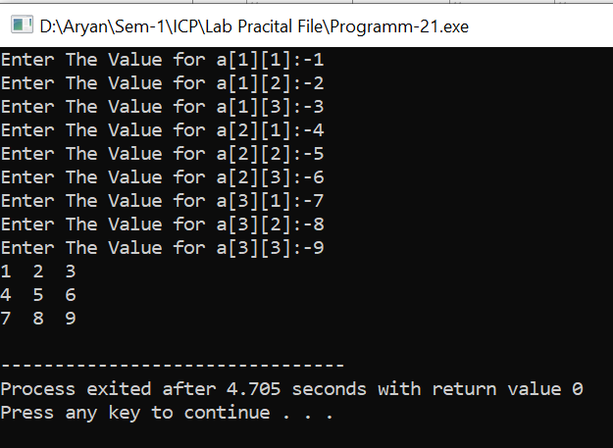

for(int i=0;i<3;i++)

{

for(int j=0;j<3;j++)

{

printf("Enter The Value

for a[%d][%d]:-",i+1,j+1);

scanf("%d",&a[i][j]);

}

}

for(int i=0;i<3;i++)

{

for(int j=0;j<3;j++)

{

printf("%d ",a[i][j]);

}

printf("\n");

}

}

**Experiment: 22**

**Aim:** Write a program to accept 5 numbers in array and find maximum and minimum value of it.

**Software:** Dev C++

**Code:**

#include<stdio.h>

int main()

{

int a[5],max,min;

for(int i=0;i<5;i++)

{

printf("Enter The Value at Index-%d:-",i+1);

scanf("%d",&a[i]);

}

max=a[0];

min=a[0];

for(int i=0;i<5;i++)

{

if(a[i]>max)

{

max=a[i];

}

}

printf("The Maximum Number In Array %d\n",max);

for(int i=0;i<5;i++)

{

if(a[i]<min)

{

min=a[i];

}

}

printf("The Minmum Number In Array %d\n",min);

return 0;

}

**Output:**

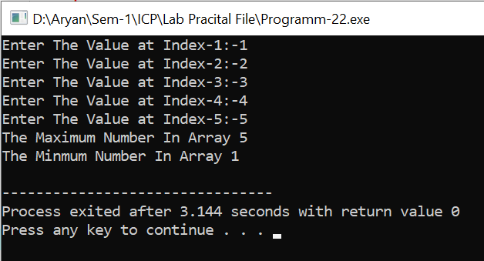

**Experiment: 23**

**Aim:**  Write a program to count number of vowels in a given string.

**Software:** Dev C++

**Code:-**

#include<stdio.h>

int main()

{

char s[15];

int num,vovels=0;

printf("Enter The String:-");

gets(s);

num=strlen(s);

for(int i=0;i<num;i++)

{

if(s[i]=='A' || s[i]=='E' || s[i]=='I' || s[i]=='O' || s[i]=='U' || s[i]=='a' || s[i]=='e' || s[i]=='i' || s[i]=='o' || s[i]=='u' )

{

vovels++;

}

}

printf("There Are %d Vovels In %s",vovels,s);

return 0;

}

**Output:** 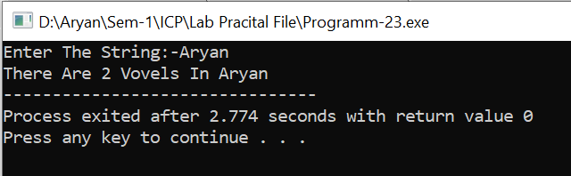

**Experiment: 24**

**Aim:**  Write a program to calculate Factorial using recursion in UDF

**Software:** Dev C++

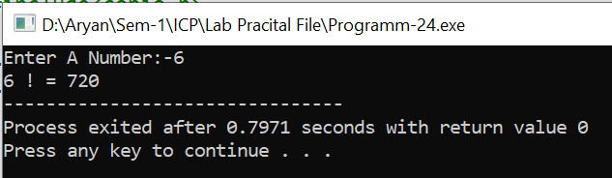**Code:-** **Output:-**

#include<stdio.h>

#include<conio.h>

int fact(int num);

int main()

{

int num;

printf("Enter A Number:-");

scanf("%d",&num);

printf("%d ! = %d",num,fact(num));

return 0;

}

int fact(int num)

{

int ans;

if(num==1 || num==0)

{

ans=1;

}

else

{

ans=num*fact(num-1);

}

return ans;

**Experiment: 25**

**Aim:-**  Write a program to find Average, maximum and minimum of Array elements using  
UDF.

**Software:-** Dev C++

**Code:-**

#include <stdio.h>

void find_avg_max_min(int arr[], int size, float *avg, int *max, int *min)

{

int i;

*max = arr[0];

*min = arr[0];

float sum = 0;

for (i = 0; i < size; i++)

{

sum += arr[i];

if (arr[i] > *max)

{

*max = arr[i];

}

if (arr[i] < *min)

{

*min = arr[i];

}

}

*avg = sum / size;

}

int main()

{

int arr[10], size, max, min;

float avg;

printf("Enter the size of the array: ");

scanf("%d", &size);

printf("Enter %d elements of the array: ", size);

for (int i = 0; i < size; i++)

{

scanf("%d", &arr[i]);

}

find_avg_max_min(arr, size, &avg, &max, &min);

printf("Average of array elements: %.2f\n", avg);

printf("Maximum of array elements: %d\n", max);

printf("Minimum of array elements: %d\n", min);

return 0;

}

**Output:-**

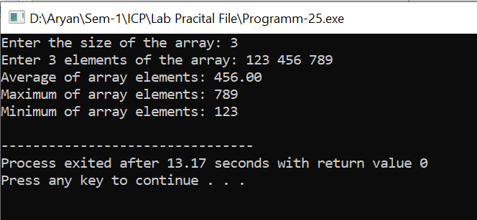

**Experiment: 26**

**Aim :-**  Write a C program to create a structure of employees with Full Name, Last Name, City and Salary. Display it for n employees

**Software:-** Dev C++

**Code:-**

#include<stdio.h>

struct employee_detail

{

char first_name[10];

char last_name[10];

char city[15];

int salary;

};

int main()

{

int n;

printf("Enter The Number Of Employee:-");

scanf("%d",&n);

struct employee_detail employee[n];

for(int i=0;i<n;i++)

{

printf("Enter The First Name Of Employee-%d:-",i+1);

scanf("%s",&employee[i].first_name);

printf("Enter The Last Name Of Employee-%d:-",i+1);

scanf("%s",&employee[i].last_name);

printf("Enter The City Of Employee-%d:-",i+1);

scanf("%s",&employee[i].city);

fflush(stdin);

printf("Enter The Salary Of Employee-%d:-",i+1);

scanf("%d",&employee[i].salary);

}

for(int i=0;i<n;i++)

{

printf("\n\n\n");

printf("First Name:- %s\n",employee[i].first_name);

printf("Last Name:- %s\n",employee[i].last_name);

printf("City:-%s\n",employee[i].city);

printf("Salary:-%d\n",employee[i].salary);

}

return 0;

}

**Output:-**

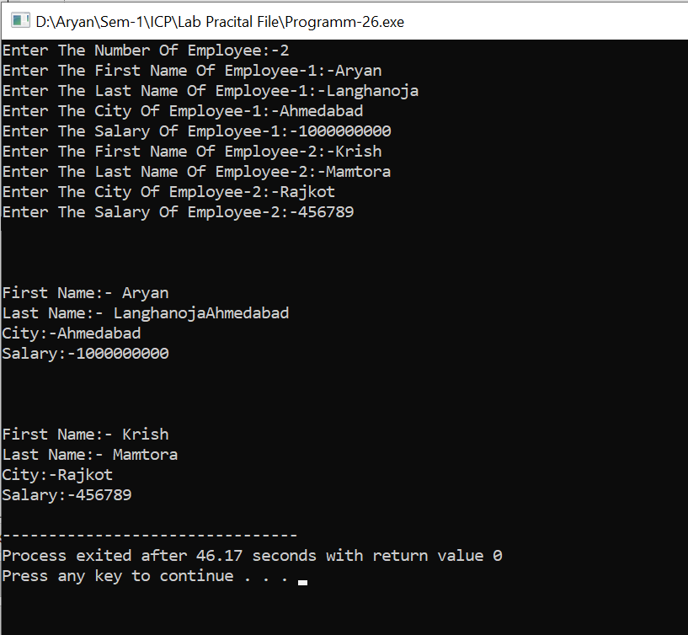

**Experiment:27**

**Aim:-**  Write a program to create array of structure. Make a structure for student having  
student_no, student_name, student_marks

**Software:-** Dev C++

**Code:-**

#include<stdio.h>

struct student_details

{

char name[30];

int marks;

int no;

};

int main()

{

int n;

printf("Enter The Number Of Student:-");

scanf("%d",&n);

struct student_details student[n];

for(int i=0;i<n;i++)

{

printf("Enter The Name Of Student-%d:-",i+1);

scanf("%s",&student[i].name);

printf("Enter The Marks Of Student-%d:-",i+1);

scanf("%d",&student[i].marks);

printf("Enter The Roll-no Of Student-%d:-",i+1);

scanf("%d",&student[i].no);

}

for(int i=0;i<n;i++)

{

printf("\n\n\n");

printf("The Name Of Student-%d:- %s\n",i+1,student[i].name);

printf("The Marks Of Student-%d:-%d\n",i+1,student[i].marks);

printf("The Roll-no Of Student-%d:-%d\n",i+1,student[i].no);

}

}

**Output:-**

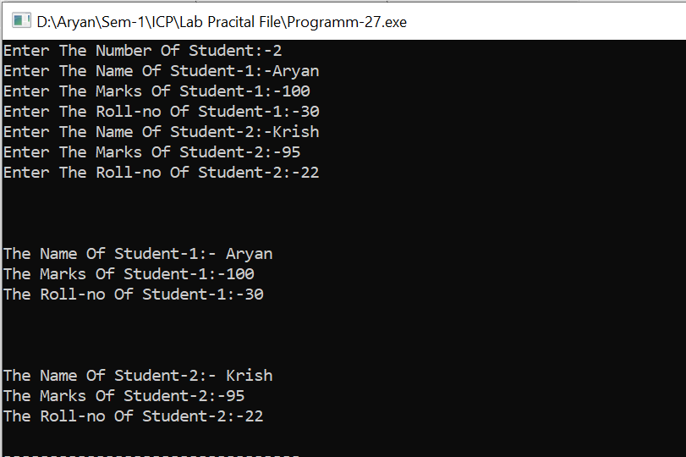

**Experiment: 28**

**Aim:-** Write a program to create union cricketer having player_name, batting_avg, player_age.P for swapping of two values with help of UDF and call by reference

**Software:-** Dev C++

**Code:-**

#include<stdio.h>

union cricketer

{

float batting_avg;

int player_age;

};

union cricker_name

{

char player_name[50];

};

void swap (float *a,float *b)

{

float temp;

temp=*a;

*a=*b;

*b=temp;

printf("After Swap:-\n");

printf("Average Of Player-1=%.2f\nAverage Of Player-2=%.2f",*a,*b);

}

int main()

{

int n;

printf("Enter The Number Of Players:-");

scanf("%d",&n);

union cricketer player[n];

union cricker_name name[n];

float avg[n];

for(int j=0;j<n;j++)

{

printf("Enter The Name Of Player-%d:-",j+1);

scanf("%s",&name[j].player_name);

}

for(int i=0;i<n;i++)

{

printf("Enter The Batting Average Of Player-%d:-",i+1);

scanf("%f",&player[i].batting_avg);

avg[i]=player[i].batting_avg;

printf("Enter The Age Of Player-%d:-",i+1);

scanf("%d",&player[i].player_age);

printf("\n\n");

}

printf("Before Swap:-\n");

for(int k=0;k<n;k++)

{

printf("The Name Of Player-%d Is %s\n",k+1,name[k].player_name);

printf("The Batting Average Of Player-%d Is %.2f\n",k+1,avg[k]);

printf("The Age Of Player-%d Is %d\n",k+1,player[k].player_age);

}

swap(&avg[0],&avg[1]);

}

**Output:-**

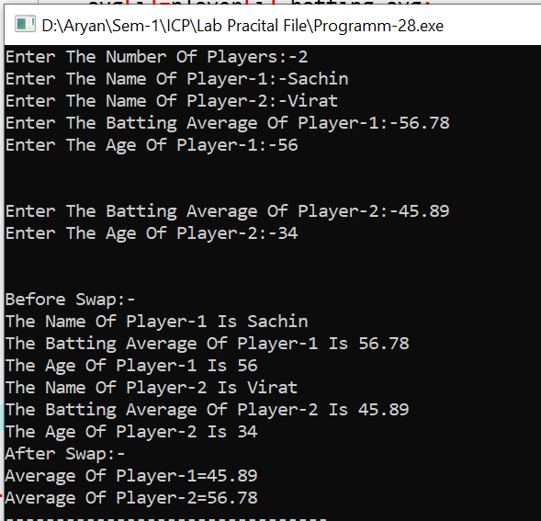

**Experiment: 29**

**Aim:** Write a program to Display contents of a file on screen. Use functions (fopen,fclose,  
getc,putchar,eof)

**Software:** Dev C++

**Code:**

#include<stdio.h>

#include<string.h>

#include<stdlib.h>

int main ()

{

FILE *fptr;

fptr=fopen("text.txt","r");

char ch;

char text[100];

ch= fgetc(fptr);

while(ch!=EOF)

{

printf("%c",ch);

ch=fgetc(fptr);

}

fclose(fptr);

}

**Output:**

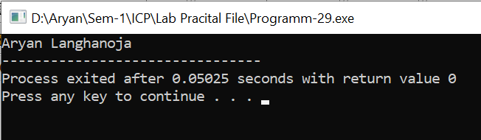

**Experiment: 30**

**Aim:** Write a program to count number of characters in a file.

**Software:** Dev C++

**Code:**

#include<stdio.h>

#include<string.h>

#include<stdlib.h>

int main ()

{

int count =0;

char ch;

FILE *fptr;

fptr=fopen("text.txt","r");

ch=getc(fptr);

if(fptr==NULL)

{

printf("Can't open file. Make sure file exits.\n");

exit(1);

}

do

{

ch = fgetc(fptr);

count++;

}while(ch!=EOF);

fclose(fptr);

printf("amount of charcter in file :- %d",count);

return 0;

}

**Output:**

